A Project Report

*On*

***Inventory Management System***

*By*

***Atharva Shiralkar***

***&***

***Sarvesh Kher***

**Acknowledgements**

It gives us great pleasure in presenting the preliminary project report on Inventory Management System

I would like to take this opportunity to thank my internal guides of **IACSD** for giving me all the help and guidance I needed. I am really grateful to them for their kind support. Their valuable suggestions were very helpful

I am also grateful to Mr. Prashant Karhale and Mr. Rohit Puranik , Course Coordinators Institute for Advanced Computing and Software Development for their indispensable support, suggestions.

Atharva Shrialkar

Sarvesh kher

**i**

**Contents**

|  |  |  |  |
| --- | --- | --- | --- |
| **Sr. No.** | **Topic** | | **Page No.** |
|  | **Acknowledgement** | | i |
|  | **Contents** | | ii |
|  | **Abstract** | | iii |
| **Chapter-1** | **Introduction** | | 1 |
|  | 1.1  1.1.1 | Motivation  Sub-Subtitles | 1  1 |
|  | 1.2 | Problem Statement | 2 |
|  | 1.3 | Framework of the Proposed Work in Project | 2 |
| **Chapter-2** | **Literature Review** | | 4 |
|  | 2.1 | Daily Used System | 4 |
|  | 2.2 | Proposed Methodologies | 4 |
| **Chapter-3** | **Software Requirement Specification** | | 5 |
|  | 3.1 | Hardware Requirements | 5 |
|  | 3.2  3.3  3.3.1  3.3.2 | Software Requirements  Technologies Used  MongoDB  Difference between MongoDB & RDBMS | 5  5  7  8 |
| **Chapter-4** | **Assumptions** | | 9 |
| **Chapter-5** | **Forms & Reports** | | 10 |
| **Chapter-6** | **Features** | | 19 |
| **Chapter-7** | **Conclusion**  7.1 Conclusions  7.2 Future Work | | 20 |

**Chapter-8 Reference** 21

**ii**

**Abstract**

Inventory Management System is software which is helpful for the businesses operate hardware stores, where storeowner keeps the records of sales and purchase. Mismanaged inventory means disappointed customers, too much cash tied up in warehouses and slower sales. This project eliminates the paper work, human faults, manual delay and speed up process. Inventory Management System will have the ability to track sales and available inventory, tells a storeowner when it's time to reorder and how much to purchase. Inventory Management System is a windows application developed for Windows operating systems which focused in the area of Inventory control and generates the various required reports

This paper describes the Inventory Management System sufficiently to determine the feasibility and usability of a finished system. The core concept is to track the number of items in the Storage with additional features for interpreting the data. It uses a basic connectivity model with a connected database to allow multiple stores to be connected. This allows for later expansion while still supporting the targeted small businesses.

**iii**

**Chapter 1**

**Introduction**

* 1. **Motivation**

Inventory Management Systems is a key instrument for businesses when tracking their inventory. Typically, Inventory Management Systems are used by firms that either sell a product or manufacture a product for purposes of accounting for all the tangible goods that allow for a sale of a finished product, or parts for making a product. The size and volume of a firm help dictate whether or not a firm is in need of such a system as they can be quite extensive and costly. Large firms that have thousands of components must have a system in place for the primary objective of tracking their assets. There are three main reasons why an Inventory Management System is needed such as timing/lead time, forecasting, and utilizing economies of scale.

* + 1. **Sub-subtitles**

The Inventory Management System is no different from any other information system in that there are factors that make it successful. The basis for this report is premised on the five components as outlined in our book. These five critical components are hardware, software, data, procedures and people. As these factors are discussed throughout the next several sections it becomes evident that they are contingent upon one another, and frankly will not function efficiently without the other.

**1**

* 1. **Problem Statement**

For storing Product information added by Vendors in Single Database Table, we are tasked to build up Inventory Management System.

This is done to replace the manual entering and processing of Product Data which are error prone and tedious. This system also maintains the Product Records as well as Vendor Record.

The system will have a Windows based desktop interface to allow the admin to Search, View and Print records and generate various reports.

For security reasons, the administrator only can Delete, Search, View and Print the information. First the Vendor needs to Register to the system for Using it.

* 1. **Framework of the Proposed work in Project**

In this Project we have covered multiple operations. They are as follows

1. ***Insert Record***

In Insert operation we are Taking Multiple Strings as Input which are Stored in MongoDB database. For example, Vendor Information such as Vendor Name, Shop Name etc. in one Collection and Product Information Such as Product name, Product Type etc. into another collection.

1. ***Update Record***

Same as Insert operation we are updating our Collection in Database by using product ID as Key to match information as Described in Query and to update a Specific Row.

1. ***Delete Record***

We are using Product ID as unique key to fetch record in Database and Delete it.

1. ***Search Record***

In this Project we are Searching records by using Product ID for Product Search and Shop name for Vendor Search

1. ***View Records***

In this project we are using JTable to Display the Records present in Collections such as Vendor Information, Product Information.

**2**

1. ***Print Records***

To Print records, we are using Database to Fetch the Data and Convert it into PDF File on Computer. Vendor Information as well as product Information can be Printed by using print Function.

**3**

**Chapter 2**

**Literature Review**

**2.1 Daily Used System**

The existing system is fully manual. Where multiple vendors have to go to the Warehouse or Inventory and Manually Fill up the Entry form which is Time Consuming process. To provide ease of use and better environment to the Inventory Management system, the movement from the existing manual system to a computerized system, so as to desire the additional benefits such as increase operation efficiency, reduced paper work and integration of various systems, was required.

Current process includes lot of Paperwork and efforts to keep track of the Data. But by upgrading it we can have less human interference and more Accuracy.

**2.2 Proposed methodologies**

In the proposed system, there are various controls to provide user friendliness. It provides high level of security, and there is no risk of data mismanagement. Proposed system encompasses study of present system thus finding out Drawbacks of the system, requirement analysis, planning and scheduling, design Development, testing, installation trails runs with small pieces of live data and Training the user (vendor) to use and also to maintain the system for the better use. The proposed system maintains consistency of data throughout the system. It contains normalized data which is easy to store and retrieve from. The proposed system will require less manpower.

**4**

**Chapter 3**

**Software Requirements and Specifications**

**3.1 Hardware Requirements**

|  |
| --- |
|  |
| Processor               **:**    Intel core processor.  RAM **:** 512MB  HardDisk              **:**    20 GB or more |

**3.2 Software Requirements**

Operating System                   **:**      Window 7 & windows 8.1

Programming Language           **:**      Java

IDE **:** NetBeans IDE 8.1

Database                                 **:**      MongoDB

**3.3 Technologies Used**

3.3.1 Java

Java programming language was originally developed by Sun Microsystems which was initiated by James Gosling and released in 1995 as core component of Sun Microsystems Java.

**Features of java**

* **Object Oriented** − In Java, everything is an Object. Java can be easily extended since it is based on the Object model. Object-oriented means we organize our software as a combination of different types of objects that incorporates both data and behaviour. Object-oriented programming (OOPs) is a methodology that simplify software development and maintenance by providing some rules.

**5**

|  |
| --- |
| **Basic concepts of OOPs are:** |
| 1. Object 2. Class 3. Inheritance 4. Polymorphism 5. Abstraction 6. Encapsulation |

* **Platform Independent** − Unlike many other programming languages including C and C++, when Java is compiled, it is not compiled into platform specific machine, rather into platform independent byte code. This byte code is distributed over the web and interpreted by the Virtual Machine (JVM) on whichever platform it is being run on.
* **Simple** − Java is designed to be easy to learn. If you understand the basic concept of OOP Java, it would be easy to master.
* **Secure** − With Java's secure feature it enables to develop virus-free, tamper-free systems. Authentication techniques are based on public-key encryption.
* **Architecture-neutral** − Java compiler generates an architecture-neutral object file format, which makes the compiled code executable on many processors, with the presence of Java runtime system.
* **Portable** − Being architecture-neutral and having no implementation dependent aspects of the specification makes Java portable. Compiler in Java is written in ANSI C with a clean portability boundary, which is a POSIX subset.
* **Robust** − Java makes an effort to eliminate error prone situations by emphasizing mainly on compile time error checking and runtime checking.
* **Multithreaded** − With Java's multithreaded feature it is possible to write programs that can perform many tasks simultaneously. This design feature allows the developers to construct interactive applications that can run smoothly.
* **Interpreted** − Java byte code is translated on the fly to native machine instructions and is not stored anywhere. The development process is more rapid and analytical since the linking is an incremental and light-weight process.

**6**

* **High Performance** − With the use of Just-In-Time compilers, Java enables high performance.
* **Distributed** − Java is designed for the distributed environment of the internet.
* **Dynamic** − Java is considered to be more dynamic than C or C++ since it is designed to adapt to an evolving environment. To verify and resolve accesses to objects on run-time.

**3.3.1 MongoDB**

## MongoDB is an open-source document database and leading NoSQL database. MongoDB is a cross-platform, document oriented database that provides, high performance, high availability, and easy scalability. Instead of storing data in tables here rows are replaced by Documents (basic unit of Data in Mongo DB just like a ROW in RDMS) and Collections (collection is a group of documents.) which allow representing complex relationships. It can manage huge amount of data and can load data across a cluster. Mongo DB can perform some features which relational database cannot do.

## Database

Database is a physical container for collections. Each database gets its own set of files on the file system. A single MongoDB server typically has multiple databases.

**Collection**

Collection is a group of MongoDB documents. It is the equivalent of an RDBMS table. A collection exists within a single database. Collections do not enforce a schema. Documents within a collection can have different fields. Typically, all documents in a collection are of similar or related purpose.

**Document**

A document is a set of key-value pairs. Documents have dynamic schema. Dynamic schema means that documents in the same collection do not need to have the same set of fields or structure, and common fields in a collection's documents may hold different types of data.

**Features of mongodb**

* Mongo DB supports Map reduce and Aggregation Tools.
* Java Scripts are used instead of Procedures.
* Mongo DB is a schema less Database.
* Simple to Administer the Mongo DB in cases of failures.
* MongoDB stores files of any size without complicating your stack.

**7**

**3.3.2 Difference between MongoDB and Relational Database**

* RDBMS (SQL):
* Frequent CRUD transactions for a limited similar type of data in GBs.
* It’s good for structured data.
* This kind of database is tightly structured with schema and perform slower (low latency) with huge growing data.
* RDBMS performs faster for low amount of data (in GBs).
* SQL DBs- Oracle, MySQL, SQLServer etc.
* MongoDB (No-SQL):
* Write once and read many for unstructured data.
* It’s faster than RDBMS for growing data on clusters/cloud in TB, PB etc.
* If there is a requirement to not update DB frequently (not mission critical), dissimilar data, then go for this.
* No SQL DBs- MongoDB, Cassandra, NeoJ, CouchDB, Hadoop, Cloudera, MapR etc.

**8**

**Chapter 4**

**Assumptions**

1. Our project is Limited to Only One Database.
2. That database consists of two collections ‘regivendor’ and ‘innsertproduct’ for Vendor Registration and Product Information respectively.
3. The Admin only allowed to Delete, Search, View and Print Data from Collections.
4. The Vendor(User) are allowed to Register, Update, Search from Database.
5. Only Administrator have Login ID and Password Level of Authentication.
6. There is no Authentication provided for Vendors.

**9**

**Chapter 5**

**Forms & Reports**

**E-R Diagram**

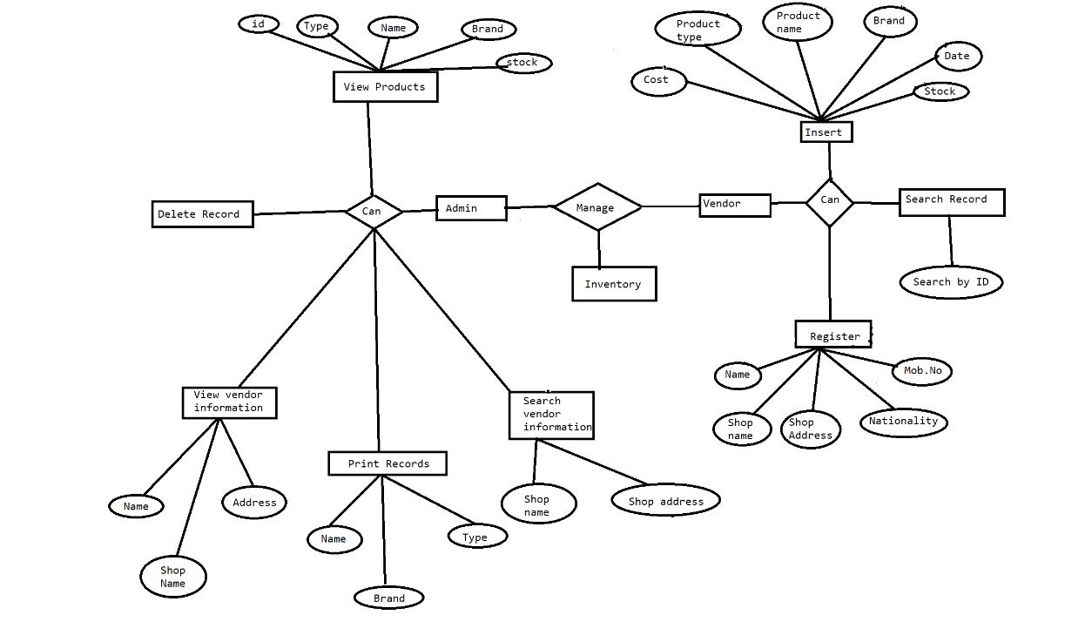

**Use Case Diagram**

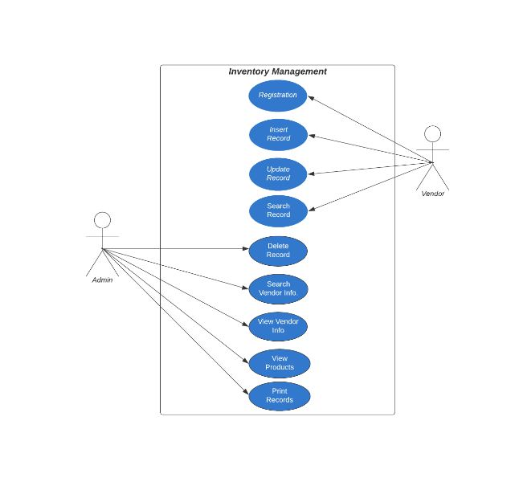

**10**

**Home Page**

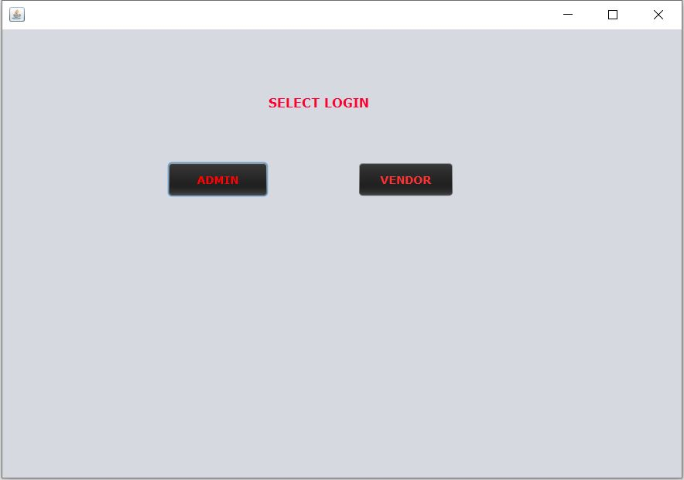

**Vendor Form**

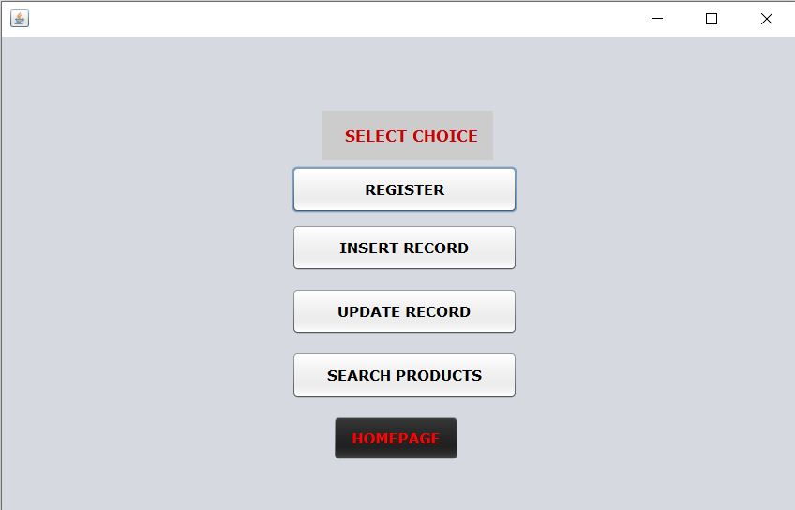

**11**

**Vendor Registration**

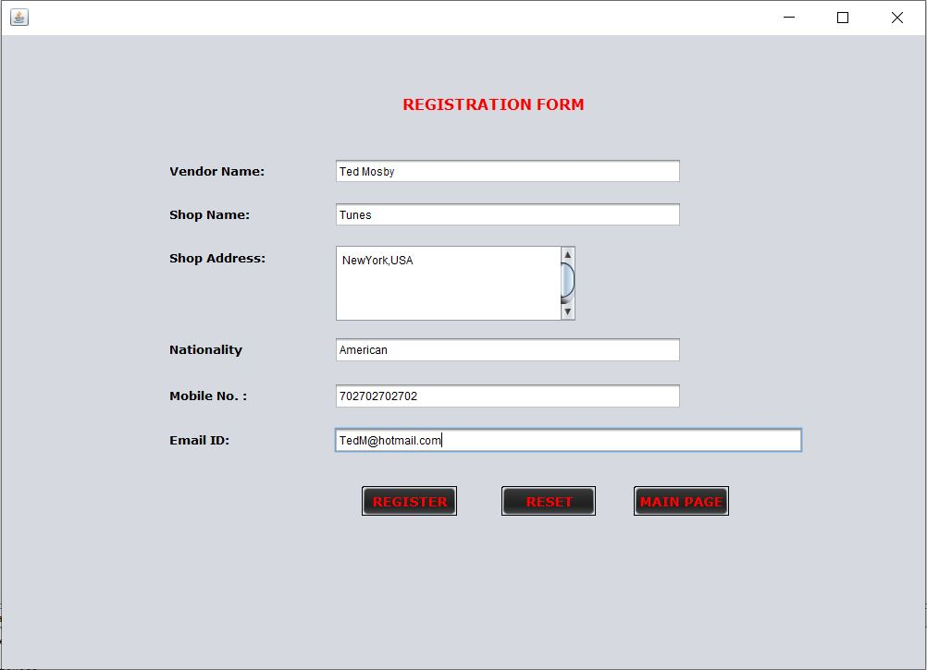

**Insert Record**

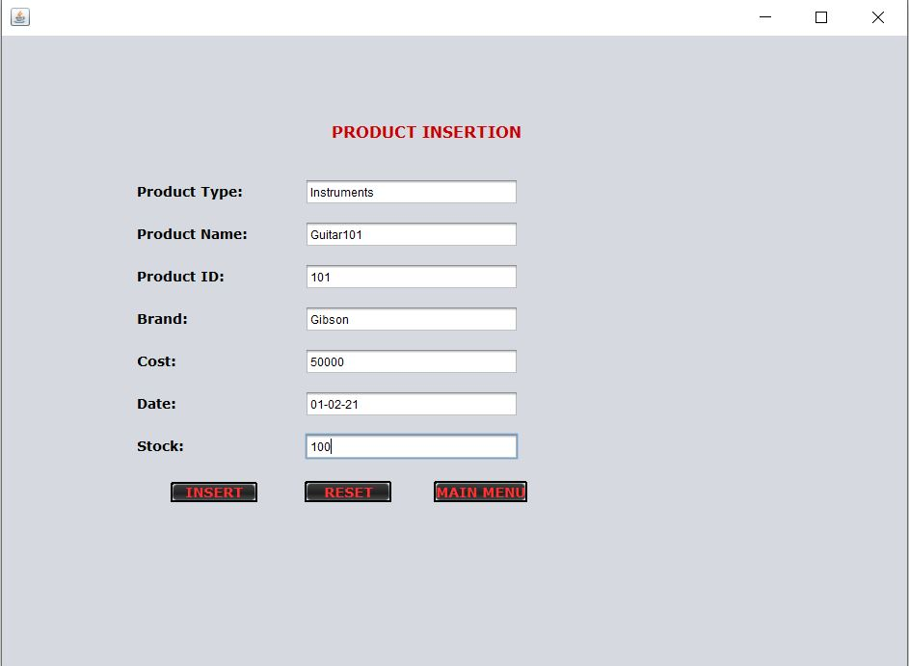

**12**

**Update Record**

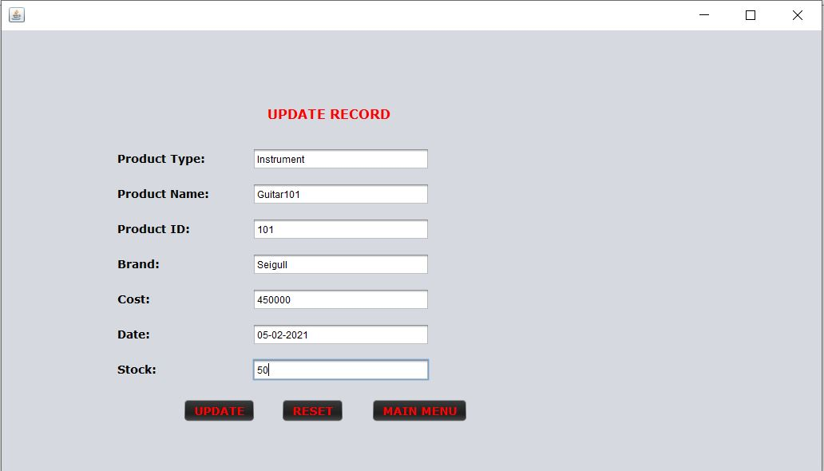

**Search Record**

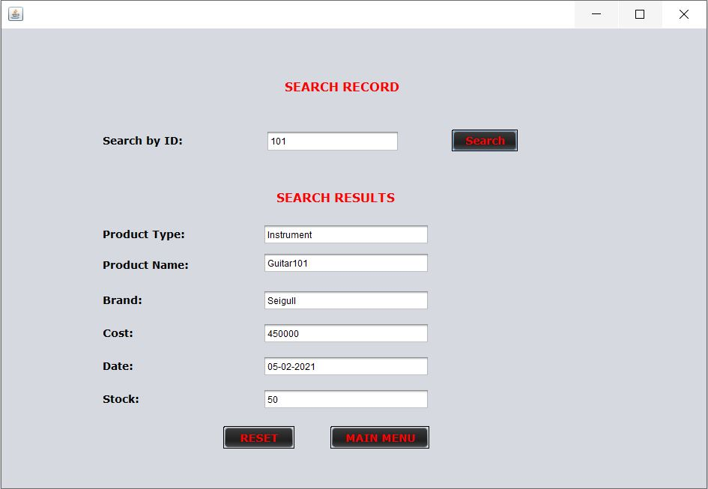

**13**

**Admin** **Login**

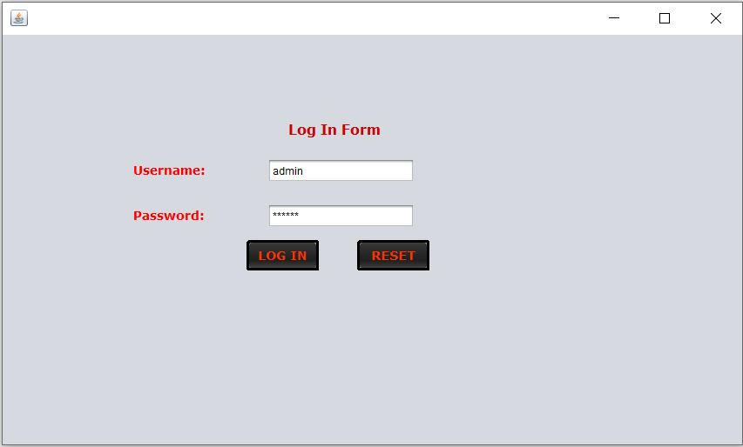

**Admin Form**

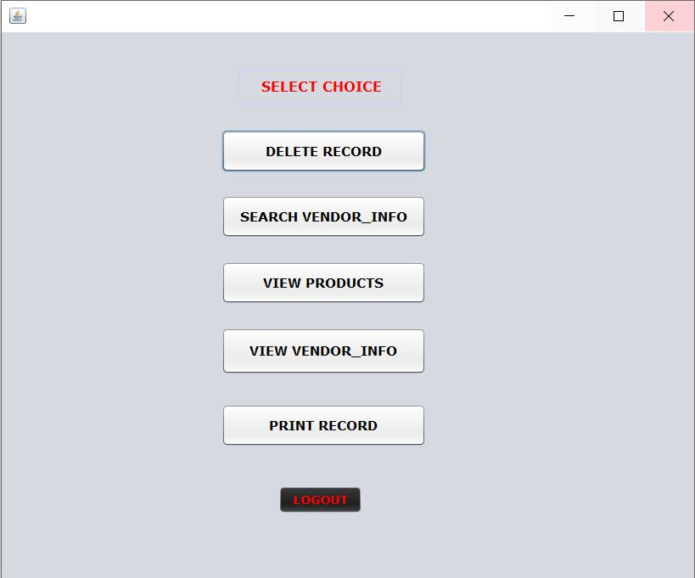

**14**

**Delete Form**

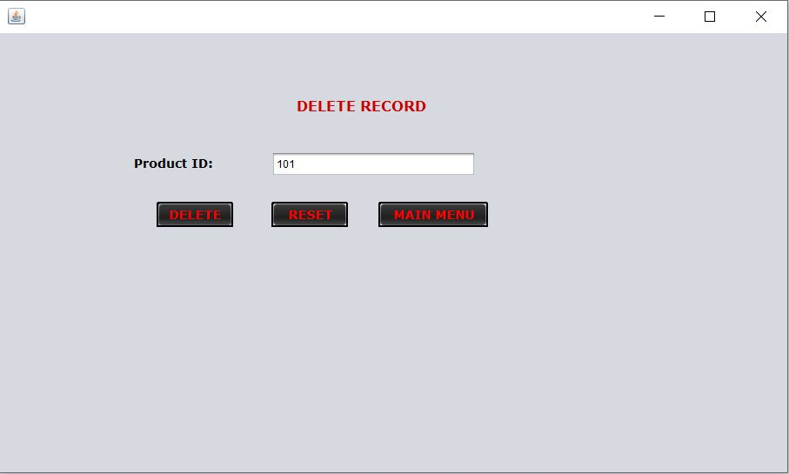

**View Products**

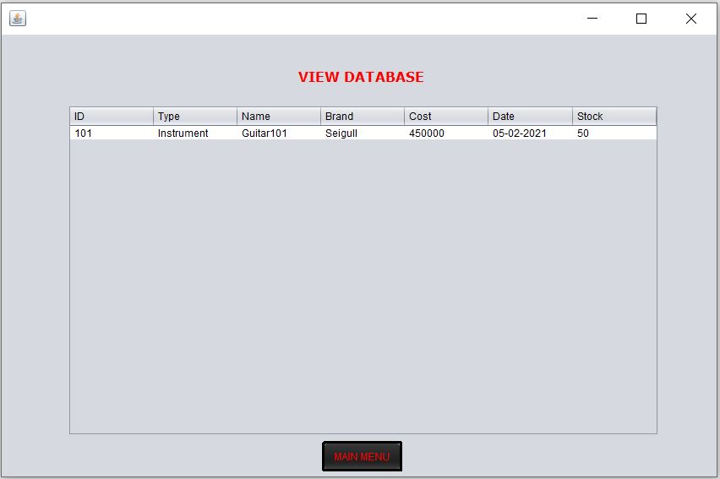

**15**

**View Vendors**

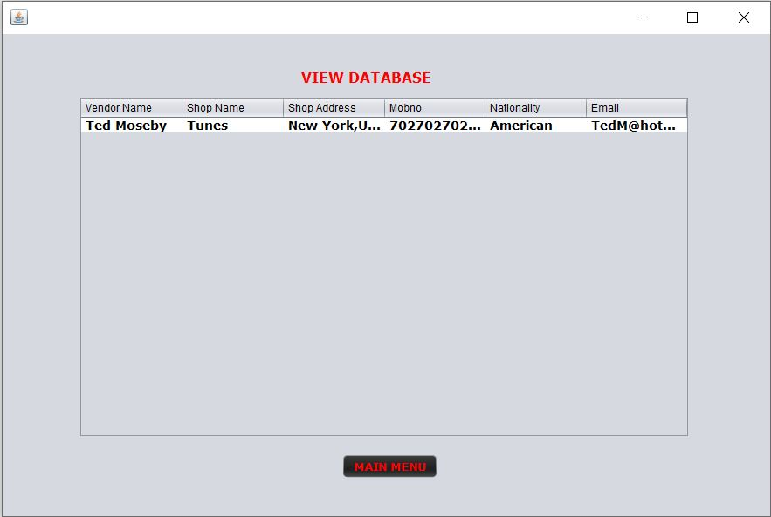

**Search Vendor**

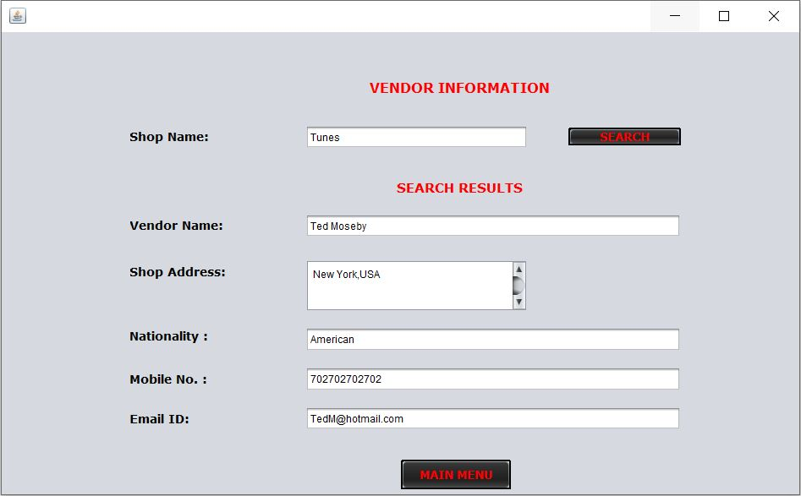

**16**

**Print Records**

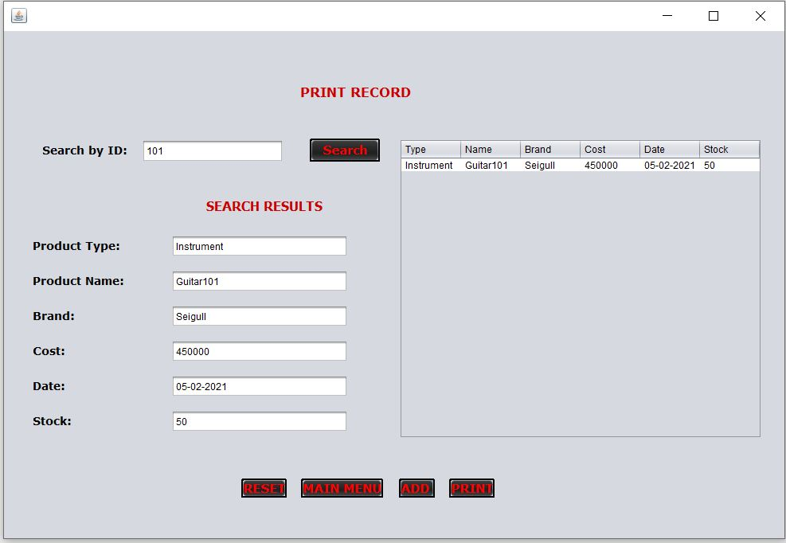

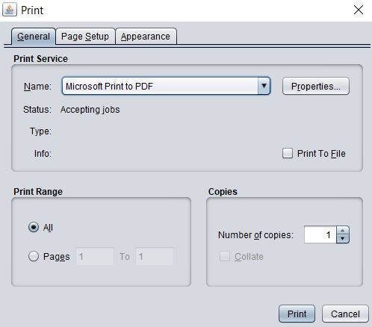

**17**

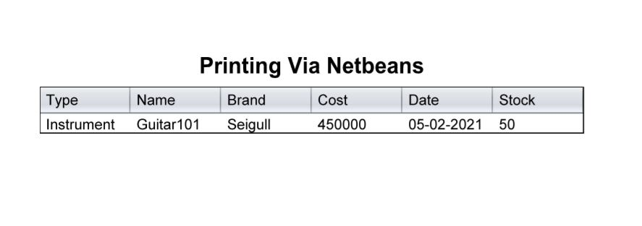

**18**

**Chapter 6**

**Features**

* User friendliness is provided in the application with various controls.
* The system makes overall project management much easier and flexible.
* Vast amount of data can be stored.
* The Product Information can be easily updated.
* We can save a lot of time which is a major factor.
* The login and password page secures the system properly.
* Print Function allow us to Create PDF File of Required Data Records.

**19**

**Chapter 7**

**Conclusion**

**7.1 Conclusion**

The proposed Inventory Management System Project is a very effectively efficient GUI-based component. This project is well tested; it works properly to meet the user requirements as described in the project. Currently the system is giving all the required Product details; various future enhancements such as Product Sorting, Vendor Authentication, Product Count etc. can be incorporated into the system.

**7.2 Future Work**

Although the Basic Database Operations are working but in future we have to Upgrade the system by adding Counting of Products, Sorting of Products, Sending Notification to Registered Vendors etc. the project can be Turn into Dynamic Working and it will be Easy to use because of Simple GUI

**20**

**Chapter 8**

**References**

* Henery H. Korth (2005) “Database System Concept”, fifth edition
* Kristina Chodorow, Michael Dirolf,"MongoDB: The Definitive Guide"
* Herbert Schildt, Java Complete Reference, 5th edition
* <http://www.codewithc.com/student-result-processing-system-java-project/>
* <https://www.tutorialspoint.com/java/java_overview.htm>
* <https://www.tutorialspoint.com/mongodb/>

**21**